SCHOOL OF GEOGRAPHY  UNIVERSITY OF LEEDS | 
COURSEWORK COVERSHEET

Student ID number | 2 | 0 | 1 | 9 | 1 | 0 | 5 | 4 | 3
Module code | GEOG5405M
Module title | Urban Data Science Project
Assignment title | Practical Briefing
Marker

Declared word count | 4995

Use of Generative Artificial Intelligence (Gen AI) in this assessment – mark one box as appropriate
I have made no use of Gen AI | X
I have used Gen AI only for the specific purposes outlined in my acknowledgements

By submitting the work to which this sheet is attached you confirm your compliance with the University’s definition of Academic Integrity as: “a commitment to good study practices and shared values which ensures that my work is a true expression of my own understanding and ideas, giving credit to others where their work contributes to mine”. Double-check that your referencing and use of quotations is consistent with this commitment.

You also confirm that your declared word count accurately reflects the number of words in your submission, excluding the overall title, Gen AI use acknowledgement, bibliography/reference list, text/numbers in tables and figures (although table and figure captions are included in the word count).

Analysing crime patterns in London using environmental features and functional zones derived from street view images

Name: HUAIYU TIAN
Date of submission: 08/2025

A dissertation submitted in partial fulfilment of the requirements of the Masters Degree in Urban Data Science and Analytics of the University of Leeds

Abstract

This project aims to explore how visible street features and functional zones influence crime patterns in London. Using a sample of London street view images, the project applies computer vision to interpret these images to quantify buildings, roads, vegetation, and other features, inferring functional zone usage, and then matches these metrics with police crime records. The findings highlight three key aspects. First, crime rates are highly uneven across the city and closely correlate with daily use patterns. Crime rates are highest in commercial and educational areas, while industrial and natural areas have lower rates. Second, street form is crucial. Dense buildings and dense vegetation are associated with higher rates of certain property crimes and disorderly offences, while open sightlines are associated with lower crime rates. Third, contextual factors cannot be ignored. The same feature may increase risk in one area while reducing it in another. The conclusion is that there is no single rule for safety design. Effective prevention measures must be tailored to function and location, integrating design and maintenance with the rhythm of each area.

Acknowledgments

I would like to acknowledge my thanks and extend my sincere appreciation to my supervisor, Weiming Huang, for his guidance and support throughout this project. I am grateful to the open-source communities, which made the data and tools used in this study available. I am deeply thankful to my parents for their support and understanding. And special thanks to the big-eyed campus bunny for its companionship.

Contents
1. Introduction 1
2. Literature Review 2
2.1 Crime and Urban Functional Zones 3
2.2 Street Features and Crime in Context 4
2.3 Recent Advances in Functional Zone Environmental Integration 5
3. Methods 6
4. Key Findings 7
4.1 Crime Distribution is Closely Related to Urban Functional Zones 8
4.2 Street Features Matter, but Their Effects Vary 9
4.3 The Same Feature Has Opposite Effects by Zone 11
5. Implications for Policy and Practice 12
6. Limitations and Future Work 13
7. Conclusion 15

Introduction

Crime not only causes social unrest but also slows sustainable city development. It is widely seen as a major barrier to urban progress. As cities expand and develop, accelerated population mobility, uneven resource distribution and weakened community ties often create conditions conducive to the growth of crime and pose greater challenges to urban governance (Algahtany and Kumar, 2016). As one of the most influential cities in the world, London's crime rate has always been at a high level. Although according to the Mayor's Office for Policing and Crime, London's overall crime rate has shown a downward trend in recent years (MOPAC, 2024). This is partly due to ongoing policing strategies and governance efforts, such as strengthening community policing, targeted crackdowns on violent crime, and the promotion of crime prevention programs. However, the city still has a considerable number of cases related to violence, theft, and public disorder. Although these policing strategies and socioeconomic measures have alleviated the crime problem to some extent, they are difficult to fully explain the significant crime differences between different regions.

Many recent studies have pointed out that in addition to these social factors, an equally critical dimension is the built environment. The layout of streets, vegetation, and buildings is often viewed as a product of planning that serves residents' lives. However, their design and maintenance can also directly or indirectly influence the opportunities for crime to occur. This idea can be traced back to the concept of “eyes on the street” proposed by Jane Jacobs (1961), which emphasized that active communities could serve as natural surveillance. This concept was later systematized into Crime Prevention Through Environmental Design (CPTED), which advocates for improving the physical environment as a potentially effective crime prevention strategy (Crowe, 2013).

In recent years, an increasing number of studies have used street view imagery (SVI) to collect data on the physical environment to examine its impact on crime. However, existing research tends to seek universal conclusions that are applicable to entire cities. While well-manicured vegetation with clear views within natural areas can reduce crime risk, the situation may be different in residential and commercial areas, where obstruction by vegetation can increase burglary and theft (Nasar and Fisher, 1993). This approach ignores a fundamental urban reality: the effect of a physical feature on crime is not inherent to the feature itself but is shaped by the social and functional context in which it exists (Cole, 2019).

Based on this, it is clear that the relationship between crime and the environment cannot be treated as a single entity. Urban areas are inherently heterogeneous, with distinct social dynamics and physical forms across functional zones, such as residential, commercial and educational areas. This heterogeneity means that the same environmental features can have different impacts on crime in different settings. For example, dense vegetation in residential areas can deter crime by enhancing community surveillance, while in commercial areas, it can foster crime by creating opportunities for concealment.

To address the shortcomings of existing research and reveal the differential impacts of the built environment on crime, the analysis of this study will focus on three core questions. First, it examines whether there are significant differences in crime rates and crime composition across different urban functional zones, thereby clarifying the dominant crime types in each zone. Second, it identifies which quantifiable environmental features exhibit consistent positive or negative correlations with crime rates at the city-wide scale. Finally, and at the core of this research, it explores whether the associations between these environmental features and crime vary across functional zones. By answering these questions, this study aims to provide actionable recommendations for urban management and planning, prioritizing which elements to improve in which areas to reduce regional crime rates. This study aims to provide new perspectives for urban design, management, and maintenance to enhance urban safety. To address these questions, this study is structured as follows. The following will first review the relevant theoretical foundations, then present in detail the study's operationalization and core findings and finally discuss its policy recommendations and prospects.

Literature Review

This chapter aims to systematically review the core concepts and empirical evidence on the built environment and urban crime, laying the foundation for the analytical framework of this article. First, the spatiality of crime and environmental criminology are sorted out, explaining why functional zones are used as a key perspective to understand internal differences in cities. Secondly, the common associations between street environment and crime are summarized, and their contextual dependence is highlighted. Finally, it reviews recent advances in data collection methods, including remote sensing, points of interest (POI), and street view imagery (SVI), identifying shortcomings in the study of urban spatiality and clarifying the focus of this article.

2.1 Crime and Urban Functional Zones

When exploring the root causes of crime, academics and policymakers have long focused on socioeconomic factors and policing strategies. These include improving employment, narrowing the poverty gap, strengthening community policing and enhancing law enforcement efficiency. These measures have helped to reduce crime rates to a certain extent, but in the face of a complex and changing urban environment, relying on a single traditional method is often difficult to fundamentally solve the problem (Kappeler, Gaines and Schaefer, 2020). Therefore, it is necessary to add a more objective perspective and systematically examine the relationship between environment and crime. In their classic study of crime in American urban communities, Shaw and McKay noted, "Perhaps the unsatisfactory results of these treatment and prevention efforts have been due, in part at least, to the fact that our attention has been focused too much upon the individual delinquent and not enough upon the setting in which delinquency arises" (Shaw and McKay, 1969, p. 122). Since then, increasing evidence has demonstrated that crime is not uniformly distributed across space. For example, for burglary, significant differences in risk exist across different locations and building types (Brantingham and Brantingham, 1984). Consequently, “Place” has gradually been established as a key analytical unit for understanding crime.

Inspired by the place-based approach, many studies have gradually shifted their focus from "who commits crime" to "what situations are most likely to cause crime?" More generally, the forms, heights, and layout of buildings and streets affect crime just as mountains and hills influence flora and fauna (Felson, 2002, p. 50). To explain the mechanism behind this observation, the daily activities perspective puts this point even more bluntly: Most criminal acts require convergence in space and time of likely offenders, suitable targets, and the absence of capable guardians (Cohen and Felson, 1979, p. 188). However, this probability of simultaneous and simultaneous crime is not uniform within a city but is shaped by the daily routines, pedestrian flows and management practices of functional zones. Consequently, residential areas, commercial areas, parks and open spaces, and educational districts often exhibit different overall levels and compositions of crime. This provides a solid theoretical foundation for using functional zones as a framework for research and comparison.

The most classic explanation of this "guardianship" comes from Jacobs' (1961) concept of the eyes of the street: the more people present and visible a street is, the safer it is. Following this line of thought, Crime Prevention Through Environmental Design (CPTED) advocates reducing crime risk through natural surveillance. Crowe (2013) summarizes natural surveillance as a layout approach that maximizes the visibility of a space through the strategic placement of buildings, entrances, public activities and pedestrian flows. Designs should ensure unobstructed sightlines and adequate lighting, while minimize obstructions and hiding places, allowing those present to easily see what is happening around them, thereby strengthening daily vigilance and awareness. This design principle not only enhances residents' sense of security but also strengthens the "readability" and sense of order of the space, thereby reducing potential crime opportunities. Furthermore, these practices manifest themselves differently in different functional zones. In residential areas, greater natural surveillance is often associated with lower risk. In commercial areas, even with natural surveillance, dense pedestrian traffic and obstructive elements often associated with the opposite effect. Therefore, it is meaningful and reasonable to adopt a functional zone perspective when studying the spatial distribution of crime. This perspective helps to compare the direction and strength of the association between street features and various types of crimes in different functional zones.

2.2 Street Features and Crime in Context

Although theoretically, there is a relatively stable correspondence between street-level environmental features and different types of crime, this relationship is not one-way but varies with context and functional zone. For example, regarding street lighting, clear sightlines, the presence of people and generally well-maintained streets are more often associated with lower crime levels at night. This is because it increases visibility and surveillance, reducing the sense of opportunity for potential criminals. Conversely, streets with high levels of obstruction, excessive light-dark contrast and poor management are more likely to attract opportunistic crime (Welsh and Farrington, 2022; Painter and Farrington, 1999). However, more traffic and activity do not necessarily mean more safety. While places with more frequent human movement and an active environment increase visibility, they also increase targets and contact opportunities, thereby increasing the likelihood of crime.

Taking urban greening as an example, well-designed and properly maintained vegetation often indirectly curb crime by promoting community interaction and relieving stress. However, overgrown or poorly managed brush can create higher risks by providing hiding places for criminals and obstructing views (Donovan and Prestemon, 2012; Troy, Grove and O’Neill-Dunne, 2012). Similarly, while high-density buildings can attract more traffic from the “eyes of the street,” they also mean greater target exposure and anonymity, creating a breeding ground for robbery and theft (Browning et al., 2010). This evidence shows that more vegetation and more buildings are not necessarily good or bad in a one-way way. The key lies in the combination of permeability, maintenance level and presence. This combination of factors is not random but systematically shaped by a place’s fundamental uses and daily rhythms. For example, a well-maintained park in a residential area may become a hub for community activity; however, if it is located on the edge of an abandoned industrial area or in an under-managed marginal location, it may become dangerous due to the lack of "natural guardians".

The functional zones provide a clear context for understanding these differences. Residential areas are more likely to foster long-term presence and neighborhood attention, while transparent interfaces and well-maintained areas reduce crime risks. Commercial areas, with their dense traffic and greater anonymity, experience an increase in robbery and theft due to obstructed and complex entrances and exits (Crowe, 2013). Urban events usually gather in a few micro locations for a long time. Therefore, when interpreting "many buildings, many vegetation, and many roads", we need to return to the specific location and functional zone context and combine it with the actual situation. Only in this way can we grasp the corresponding direction and strength of different crime types. In short, the study of the relationship between street environment and crime must go beyond the single factor determinism and turn to a situational interaction analysis framework. This will reveal how the same environmental features in different functional zones affect crime through different social mechanisms.

2.3 Recent Advances in Functional Zone Environmental Integration

The above analysis shows that the research on the relationship between street environment and crime has shifted from exploring the universal effects of a single factor to a deep understanding of its situational complexity. The academic community believes that it is necessary to establish an integrated analytical framework that combines the physical environment, social mechanisms and functional zone background. This deepening of theoretical understanding also poses new challenges to research methods. In recent years, methods for collecting physical environment information on a large scale have been widely used, providing new possibilities for addressing this challenge. Currently, the main known methods can be divided into three categories. Traditional remote sensing techniques excel at depicting macroscopic land cover and urban form, making them ideal for collecting easily distinguishable information such as green areas and rivers on maps. Points of interest (POI) data effectively reflects regional activity types and functional composition, making them ideal for collecting functional zoning types and functional statistics within a region. However, both of these methods struggle to capture fine-scale differences at the street level. Emerging Street View Imagery (SVI) data addresses this shortcoming by capturing the authentic details of streets from a human-centered perspective. Street view imagery can be quantified using pre-trained models and aligned with police statistics, facilitating fine-grained analysis (Wu and Wang, 2024). At the same time, new visual language models can infer urban functions in the absence of annotations, making it possible to integrate street view image elements with functional context (Huang, Wang and Cong, 2024).

Overall, existing conclusions still have some flaws. Many studies only present "citywide averages". They use different statistical methods and time periods, making comparison difficult. Furthermore, factors like visibility, buildings and vegetation are often considered separately, rarely discussed together. Based on these shortcomings, this article has made a summary that is closer to the latest research: at the small regional level, London's street environment information is matched with official crime records using a consistent method, and then the corresponding direction and strength of environmental features and various types of crime are examined by functional zone layer. The goal is to create a clearer zoning picture and provide a scientific basis for refined urban governance and design.

Methods

The preceding analysis demonstrates that the relationship between street environment and crime is not a simple causal relationship but rather fraught with situational complexity. To deeply understand this complex relationship, the research perspective must shift from traditional macro-map analysis to a human-centered scale that is closer to people's real experiences. Based on this prompt, this study has completed a research method that can systematically capture and analyze the streetscape of Greater London. First, approximately 150,000 street view images were uniformly sampled across Greater London, captured using a data interface from Mapillary (a massive online street view image library) according to a pre-defined grid. Once the raw images were obtained, their content was interpreted using two advanced, pre-trained computer vision models. The first model, SegFormer, performs semantic segmentation on images. This technology can accurately identify each pixel in each image as different elements such as "building", "road", "vegetation", "sky", etc., so that the physical environment composition of each street can be quantified. The second model, UrbanCLIP, learns from the associations between massive amounts of images and text to understand the functional zones of a scene. It can observe a street view and infer the probability of it belonging to a residential, commercial, or educational area. Finally, through their collaborative work, all indicators are aggregated into small neighborhood LSOA units and correlated with police public record data at the same scale, forming a comparable profile of environmental features.

This study employed two complementary statistical analysis tools. The first, Pearson correlation analysis, measures whether a stable, straight linear relationship exists between two variables. That is, when an environmental factor increases, does a certain type of crime also increase or decrease at a relatively fixed rate? However, real-world correlations are often more complex and not perfectly linear. Therefore, a second tool, Spearman correlation analysis, was introduced. This method is more flexible and looks for monotonic relationships or overall trends. In other words, it examines whether an increase in one factor leads to an overall increase or decrease in the other variable, rather than requiring a perfectly straight line. By combining these two methods, we can capture simple, straightforward associations while also noting equally important, but complex, nonlinear patterns. This comprehensive data analysis approach allows for a systematic examination of the complex relationships between environmental features and various crime types at a human scale, across diverse functional contexts. This provides a scientific basis for developing more effective urban safety strategies.

Key Findings

With the help of the above methods, this study systematically sorted out the street environment and crime situation in London at the human scale. Relying on quantitative interpretation of large-scale street view imagery and multi-dimensional statistical comparison, it produces clear and readable visualizations. Three key findings, extracted from this research, are directly relevant to urban safety governance and provide actionable evidence for the impact of the environment on crime.

4.1 Crime Distribution is Closely Related to Urban Functional Zones

The first key finding of this study is that the daily use of an area determines its crime risk features. There are obvious differences in crime rates and crime types among different functional zones. This shows that criminal activity is directly related to the daily flow of people, activity patterns and potential opportunities in a place. The situation is more straightforward in commercial areas. There are dense crowds of people and frequent transactions there, which gathers a large number of potential targets of opportunity, so the overall crime rate is significantly higher. The situation in educational areas is more unique and complex. Traditionally, university campuses are undoubtedly relatively safe areas. But in a historic metropolis like Greater London, the situation is just the opposite. Many universities and colleges do not have enclosed, self-contained campuses. Instead, their teaching buildings, libraries and student dormitories are scattered throughout different blocks of the city, fully integrated with the surrounding commercial and residential areas.

This embedded and borderless campus model creates a highly mixed function within educational districts. The activities of students, faculty, and ordinary citizens overlap significantly. Consequently, university districts resemble busy commercial areas, filled with a mobile crowd of strangers and a large concentration of potential targets. Because students are focused on school or social activities, their vigilance is relatively low, creating ideal conditions for opportunistic crime. Therefore, the high crime rate in London's education district is not due to educational activities themselves but is caused by its unique urban form. In contrast, industrial districts, with their relatively low levels of daily activity and fewer potential targets, generally have lower crime rates. However, the crime rate in residential areas is not particularly high due to the “natural surveillance” formed by long-term presence and neighborhood attention, which is consistent with the view put forward by Crowe (2013) above.

Fig.1 clearly illustrates this disparity. For example, theft and vehicle offences are the most common crimes in transportation hubs. The large number of vehicles parked and moving around creates this risk. Theft is high in all areas, but the incidence is much higher in commercial areas than in residential areas. This phenomenon demonstrates that crime prevention strategies must be tailored to the specific circumstances. We need first understand the fundamental uses and daily activity patterns of a location and then develop tailored security strategies for each area to truly and effectively reduce crime risks.

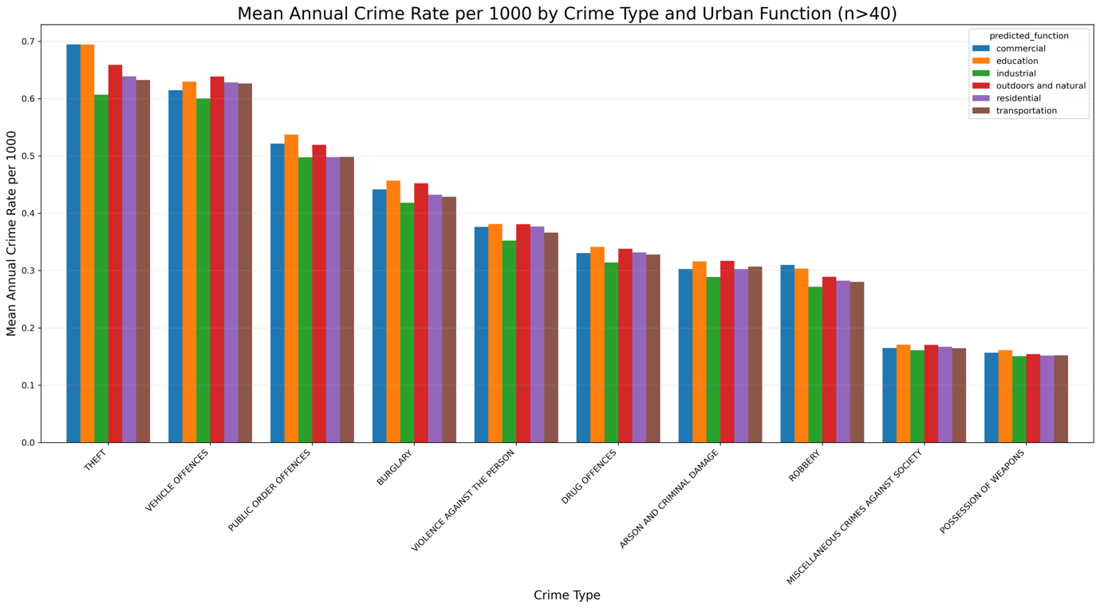
Fig.1 Comparison of average crime rates in different functional zones of London

4.2 Street Features Matter, but Their Effects Vary

The second finding is that specific features of street design, including buildings, vegetation, sky, and roads, are generally correlated with crime rates. Across the city, certain features do have relatively stable relationships with crime risk. Fig.2 shows the correlation between different street environment features and various types of crime. It can be seen that densely built environments, that is, streets with more buildings on both sides, have higher rates of theft, robbery and public order crimes. The logic behind this is very intuitive. Dense buildings mean a large flow of people, more potential targets for crime, and greater anonymity. Complex building layouts, such as alleys, may also provide criminals with convenient escape routes and hiding places.

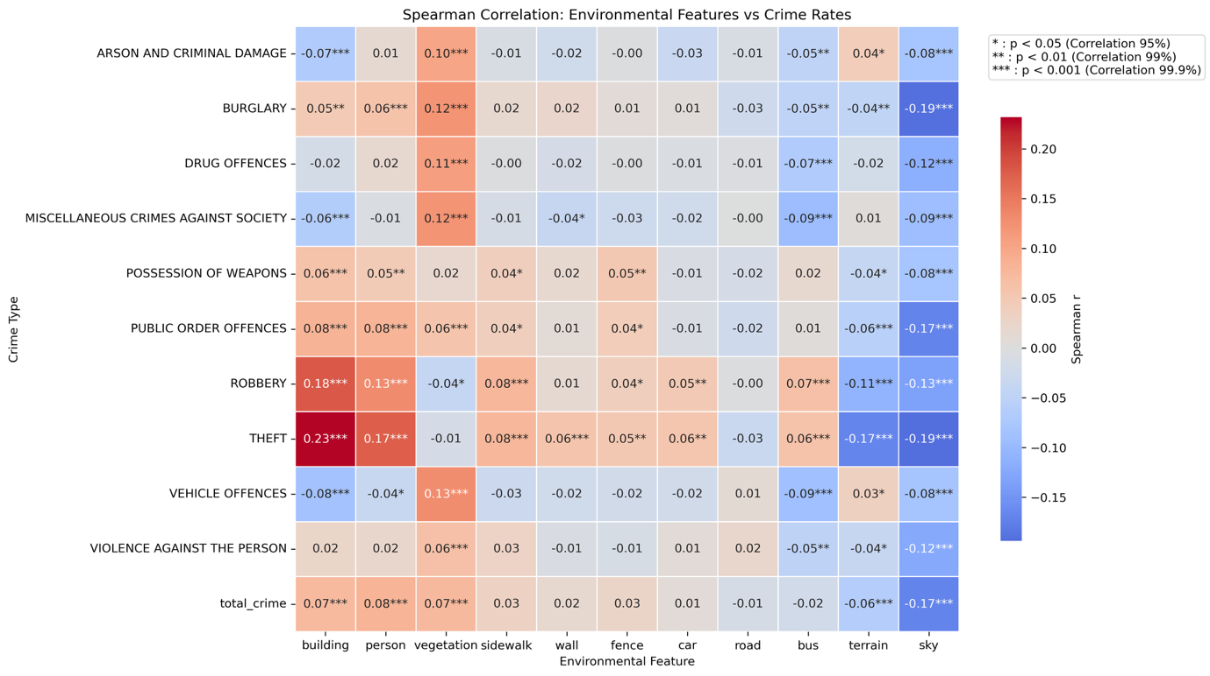
Fig.2 The correlation between different street environment features and various types of crimes

However, the impact of some features on crime is not intuitive, revealing the complexity of environmental influences. For example, the impact of urban vegetation on crime is highly complex. The analysis in Fig.2 reveals that increased vegetation cover is positively correlated with burglary, drug-related crimes, and other offences. This suggests that overly lush vegetation can provide hiding places for criminals. The key here is the level of maintenance. A well-manicured park with a clear view provides a completely different sense of security than an overgrown, unmanaged vegetation. In contrast, spatial openness—that is, a wider, unobstructed view, such as sky visibility—is negatively correlated with the incidence of nearly all crime types. It makes potential criminals feel exposed, effectively deterring them from committing crimes. This finding provides strong modern evidence for the "eyes on the street" theory.

4.3 The Same Feature Has Opposite Effects by Zone

This is the most important and practically significant finding of this study. The impact of any single environmental factor on crime is not static; it changes fundamentally depending on the functional context. This means that discussions about whether building more houses or planting more trees is beneficial or harmful, taken out of context, need to be reconsidered. For example, in commercial and educational areas, high building density is a catalyst for crime. However, in residential and industrial areas, its impact is much smaller. In compact residential areas, a stronger system of watchful relationships between neighbors may be formed, which contributes to safety.

This reverse effect is particularly evident in vegetation, as shown in Fig.3. In residential, commercial, and educational areas, more vegetation slightly increases crime. This may be because it provides hiding places for criminals. This negative effect is even more pronounced in industrial areas with few natural guardians, where green belts become desolate due to lack of human presence and easily become sites for illegal activities. However, in outdoor and natural areas, more vegetation is associated with lower crime rates. This is because well-designed vegetation in parks attract people to walk, exercise, and socialize. These active public activities themselves constitute the most effective natural surveillance, forcing criminals to consider before committing crimes. Any effective crime prevention strategy must be context-sensitive. Blindly applying a certain design standard may not only be ineffective, but may even bring unexpected negative consequences.

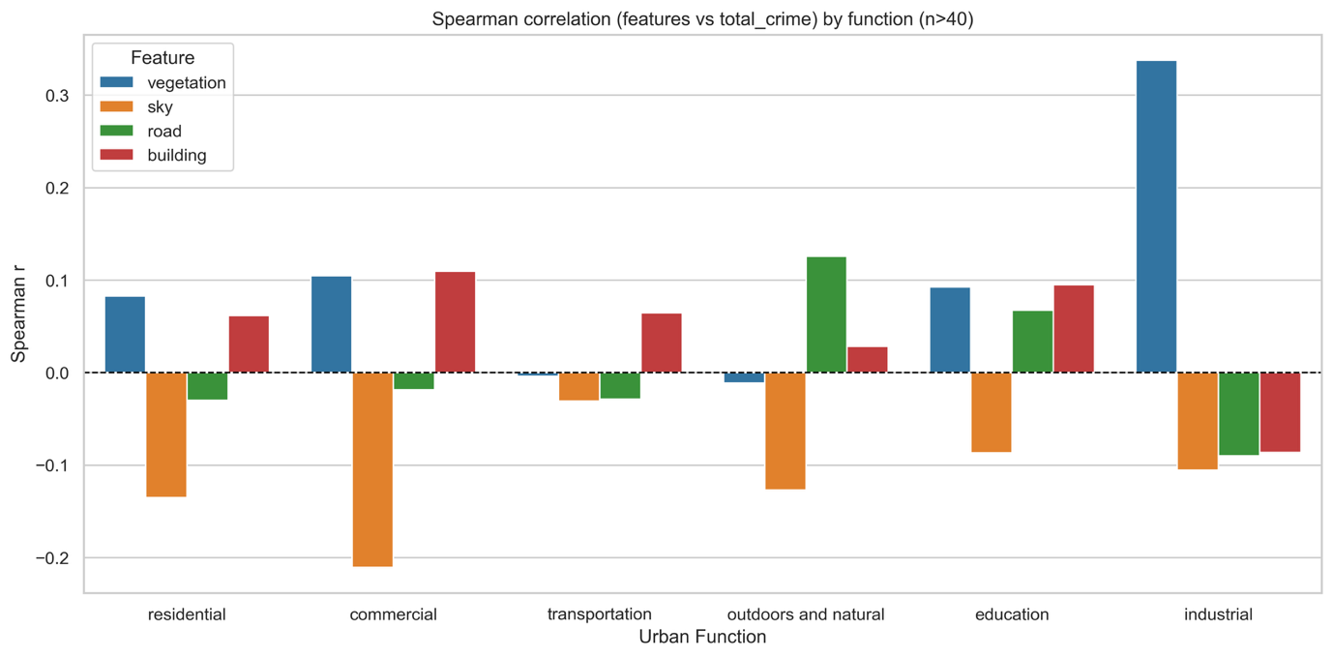
Fig.3 Variation of the relationship between vegetation coverage and crime rate in different functional zones

Implications for Policy and Practice

The findings of this study offer important practical guidance for city managers, urban planners, police departments, and community groups. The results clearly demonstrate that effective crime prevention cannot rely on a one-size-fits-all template. Instead, it must be contextually tailored and based on a deep understanding of the unique features of each urban area. The following are two key insights that translate this study's core findings into concrete policy and practice.

First, urban governance and policing strategies need to shift from traditional geographic zoning to a dynamic resource allocation model based on "functional zones." This study confirms that a place's daily use, or functional zone, is the most accurate predictor of its crime risk. Therefore, policymakers and police should deploy resources and formulate strategies based on the features of different functional zones. For example, high crime rates in commercial areas and London's unique "borderless" education zones are primarily due to large, mobile populations and a variety of criminal targets. Policing here should focus not only on routine patrols but also on increasing visible police presence during peak hours, collaborating with businesses and universities to launch awareness campaigns against theft, and improving the security design of public facilities, such as providing safer bicycle parking. For industrial areas, the strategy should focus on security during off-hours, addressing the natural surveillance vacuum created at night by strengthening lighting projects and night patrols.

Second, urban planning and design should move beyond broad guidelines and adopt evidence-based intervention strategies. This research reveals the dual nature of the impact of many physical environmental elements on crime, suggesting that indiscriminate promotion of "taken-for-granted" strategies may not only be ineffective but even counterproductive. Taking urban greening as an example, policy should focus not on simply increasing vegetation in a quantitative manner but rather on improving its quality and contextualizing its management. In residential, commercial, and educational areas with higher crime risks, interventions should focus on enhancing natural surveillance through careful design and maintenance. Specifically, plant height should be controlled to avoid hiding spots, and branches should be regularly pruned to ensure clear sightlines. Furthermore, public amenities such as benches and fitness facilities should be strategically placed to attract active public activities and increase pedestrian density. However, in areas where vegetation can curb crime, such as natural parks, the design focus should shift to enhancing accessibility and connectivity. For example, ensuring adequate lighting on internal walkways and seamlessly connecting vegetation to areas of high pedestrian flow can maximize their positive role as protective public spaces. The same principle applies to building density. Policies should focus not just on the number of buildings but also on their quality and how they interact with the street. Planning departments should encourage designs that activate street life. For example, new commercial and residential buildings could be required to have transparent glass curtain walls and active commercial areas on their ground floors, avoiding long, monotonous solid walls. In residential areas, regular activities can be held or lawns and fitness equipment can be built. This approach can effectively enhance residents' sense of territory and responsibility, thereby promoting informal community supervision.

Limitations and Future Work

Although this study has made innovations in its methods, there are still several issues that need to be carefully considered in terms of data sources, analysis methods and conclusion inference.

First, this study has inherent limitations in terms of data collection and sample representativeness. The research mainly relies on Mapillary, an open-source street view image database. While Mapillary provides a valuable open data resource, its image coverage and update frequency for the London area are still insufficient compared to the commercial Google Street View. More importantly, its data collection suffers from systematic biases, and the sampling of street view images across different functional zones and street types can be extremely uneven. For example, urban arterial roads are typically very densely sampled, while small streets and alleys within residential areas may be sparsely sampled or even absent. This imbalance results in significant differences in sample sizes across different functional zones, such as the relatively limited number of street views in industrial and natural areas, potentially limiting the robustness of the correlation results. Furthermore, the grid sampling method used in this study failed to adopt a more geometrically uniform hexagonal grid, and the collected images were not 360-degree panoramic photos, which means that environmental information on both sides and behind the street was ignored, which limits the capture of the integrity of the built environment. In future, use more than one street-image source and check that coverage is even across road types and zones. Where possible, use wider views and line up photo dates with the crime period.

Secondly, this study also has room for further development in terms of analytical methods and models. The definition of functional zones is one of the core aspects of this study. We mainly rely on the UrbanCLIP model to infer functional attributes from street view images. Although this is an innovative automated approach, its rigor still needs to be improved compared to cutting-edge research that uses multi-source data fusion (such as combining point of interest (POI) data and land use planning data). This study also simplifies the heterogeneity within functional zones. While a single LSOA may contain both residential and commercial areas, this study categorizes them according to a single dominant functional label, which may mask micro-environmental differences within the region. This internal heterogeneity may weaken the significance of the relationship between environment and crime. In future, improve zone labels by combining street view images with POI and official land-use maps. Also let one small area carry more than one use when it clearly mixes buildings, shops or schools.

Third, in terms of conclusion inference and statistical robustness, it must be emphasized that this study reveals correlation rather than causality. For example, while the analysis shows a positive correlation between building density and theft rates, this does not mean that high-density environments directly cause theft. The two may be linked by common, unmeasured underlying variables, such as the area's socioeconomic status or community cohesion. Therefore, the findings of this study should be understood as the identification of risk patterns, rather than a direct explanation of the causes of crime. In future, track places over time and compare before and after changes. Add simple background measures like local income, people flow and police presence to make the patterns more reliable.

Conclusion

This study aims to answer core questions about the relationship between the built environment and crime. Through a systematic analysis of London's streetscapes, the study first confirmed that crime is extremely unevenly distributed in urban space, with its rates and composition varying across functional zones: commercial and educational areas have a much higher crime risk than industrial and natural areas. Second, the study also identifies some general citywide associations: for example, high building density is generally associated with higher crime rates, while open views generally have a suppressive effect. However, these findings do not fully explain the complexity of crime patterns.

The core conclusion of this study is that the impact of these environmental features is not static but profoundly context dependent. The same element can have opposing effects in different functional zones: for example, vegetation may foster crime by providing hiding places in residential areas but inhibit crime by attracting active public activities in parks or university campuses. This finding directly addresses the study's initial question: it is the context of the functional zone that mediates and determines the ultimate relationship between the physical environment and crime risk. Therefore, despite limitations such as data coverage, this study clearly points to a future direction for urban safety. This requires moving beyond the traditional pursuit of universal principles and toward a deeper understanding of the unique daily activities and environmental features of each functional zone. Based on this understanding, refined and targeted intervention strategies can be developed to create more resilient and secure urban spaces.

References

Algahtany, M. and Kumar, L., 2016. A method for exploring the link between urban area expansion over time and the opportunity for crime in Saudi Arabia. Remote Sensing, 8(10), p.863. [Accessed 12 August 2025]. Available from: https://doi.org/10.3390/rs8100863

Brantingham, P.L. and Brantingham, P.J., 1984. ‘Burglar mobility and crime prevention planning’, in Clarke, R.V., Hope, T. and Newman, G. (eds.) Coping with Burglary. Dordrecht: Springer, pp. 77–96. [Accessed 13 August 2025]. Available from: https://doi.org/10.1007/978-94-009-5652-0_6

Browning, C.R., Byron, R.A., Calder, C.A., Krivo, L.J., Kwan, M.-P., Lee, J.-Y. and Peterson, R.D., 2010. Commercial density, residential concentration, and crime: Land use patterns and violence in neighborhood context. Journal of Research in Crime and Delinquency, 47(3), pp.329–357. [Accessed 19 August 2025]. Available from: https://doi.org/10.1177/0022427810365906

Cohen, L.E. and Felson, M., 2010. ‘Social Change and Crime Rate Trends: A Routine Activity Approach (1979)’. In: Andresen, M.A., Brantingham, P.J. and Kinney, J.B. (eds) Classics in Environmental Criminology. 1st edn. Abingdon: Routledge. [Accessed 19 August 2025] Available from: https://doi.org/10.4324/9781439817803-12

Cole, S., 2019. Social and physical neighbourhood effects and crime: Bringing domains together through collective efficacy theory. Social Sciences, 8(5), p.147. [Accessed 13 August 2025]. Available from: https://doi.org/10.3390/socsci8050147

Crowe, T.D., 2013. Crime Prevention Through Environmental Design. 3rd edn. Waltham, MA: Butterworth-Heinemann, pp. 36 - 47. [Accessed 16 August 2025]. Available from: https://students.aiu.edu/submissions/profiles/resources/onlineBook/a2S7e3_crime%20prevention%20environmental%20design%20architecture.pdf

Donovan, G.H. and Prestemon, J.P., 2012. The effects of trees on crime in Portland, Oregon. Environment and Behavior, 44(1), pp.3–30. [Accessed 19 August 2025]. Available from: https://research.fs.usda.gov/treesearch/42374

Felson, M., 2002. ‘The Topography of Crime’, Crime Prevention and Community Safety, 4(1), pp. 47–51. [Accessed 19 August 2025] Available from: https://doi.org/10.1057/palgrave.cpcs.8140113

Jacobs, J., 1961. The Death and Life of Great American Cities. New York: Random House. [Accessed 16 August 2025]. Available from: https://www.petkovstudio.com/bg/wp-content/uploads/2017/03/The-Death-and-Life-of-Great-American-Cities_Jane-Jacobs-Complete-book.pdf

Huang, H., Wang, S. and Cong, G., 2024. Zero-shot urban function inference with street view images through prompting a pretrained vision-language model. International Journal of Geographical Information Science, 38(1), pp.1414–1442. [Accessed 16 August 2025]. Available from: https://doi.org/10.1080/13658816.2024.2347322

Kappeler, V.E., Gaines, L.K. and Schaefer, B.P., 2020. Community policing: A contemporary perspective. 8th ed. New York: Routledge, pp.207-208. [Accessed 13 August 2025]. Available from: https://doi.org/10.4324/9780429398056

Mayor’s Office for Policing and Crime (MOPAC), 2024. MOPAC Annual Report 2023–24. [online] Greater London Authority. [Accessed 17 August 2025]. Available from: https://www.london.gov.uk/programmes-strategies/mayors-office-policing-and-crime-mopac/keep-date-mopac-work/mopac-publications/mopac-annual-report-23-24

Nasar, J.L. and Fisher, B., 1993. ‘Hot spots’ of fear and crime: A multi-method investigation. Journal of Environmental Psychology, 13(3), pp.187–206. [Accessed 13 August 2025]. Available from: https://doi.org/10.1016/S0272-4944(05)80173-2

Painter, K. and Farrington, D.P., 1999. Improved street lighting: Crime reducing effects and cost–benefit analyses. Security Journal, 12(4), pp.17–32. [Accessed 16 August 2025]. Available from: https://doi.org/10.1057/palgrave.sj.8340037

Shaw, C.R. and McKay, H.D., 1969. ‘Juvenile delinquency and urban areas: A study of rates of delinquency in relation to differential features of local communities in American cities’, in M.A. Andresen, P.J. Brantingham and J.B. Kinney (eds) Classics in Environmental Criminology. London: Routledge, p.122. [Accessed 18 August 2025]. Available from: https://www.taylorfrancis.com/chapters/edit/10.4324/9781439817803-9/

Troy, A., Grove, J.M. and O’Neill-Dunne, J., 2012. The relationship between tree canopy and crime rates across an urban–rural gradient in the greater Baltimore region. Landscape and Urban Planning, 106, pp.262–270. [Accessed 19 August 2025]. Available from: https://doi.org/10.1016/j.landurbplan.2012.03.010

Welsh, B.C. and Farrington, D.P., 2022. Effects of improved street lighting on crime: An updated systematic review and meta‐analysis. Criminology, 60(4), pp.734–763. [Accessed 16 August 2025]. Available from: https://doi.org/10.1111/1745-9133.12585

Wu, D.Y. and Wang, J., 2024. Analyzing urban crime through street view imagery: Insights from urban micro built environment and perceptions. Urban Science, 8(4), pp.1 - 15. [Accessed 16 August 2025]. Available from: https://doi.org/10.3390/urbansci8040247

